

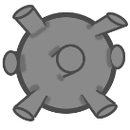
[CITY NAME]?? used to be known for being a beautiful country, but after the war there is a little beauty or food to be found – except for in War Lakes, where there are fish and nuclear bombs aplenty. Carefully fish in these dangerous waters to try and feed your family – but be quick! You’re not the only with the same idea, and you might just go home hungry if you aren’t fast enough.





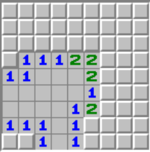
Features
Fish-Kaboom is described as a puzzle game that can be played with friends and family in a fun and free-for-all.
Players are referred to as fishers. At the same time, every fisher participates in the game.
Fishers initiates the game by clicking on random place to catch the fish in the Lake (board).
After the first move don’t just pick any random spot to fish: if you find a bomb, it will explode and take out some of your fish with you.
Fish enjoy the warmth of radiation: the more bombs there are around a fishing spot, the more fish you will find.
Use the hints left by long-gone fishers to find where bombs are located and avoid them.

